Tutorial/blog sites

Definition:
# Source: AI Source: Provided by: [Data Path: Persons Table -> ID Column: 1, Name_En Column: Motasem Essam] -> From: [Chatgpt (GPT‑5 Mini)] on [2/12/2026]
Tutorial or blog websites are websites created to share information, guides, tips, or personal/professional experiences with an audience. They focus on teaching, storytelling, or providing insights.

Simple Definition
# Source: AI Source: Provided by: [Data Path: Persons Table -> ID Column: 1, Name_En Column: Motasem Essam] -> From: [Chatgpt (GPT‑5 Mini)] on [2/12/2026]
Tutorial/blog site = a website where people write articles, guides, or tutorials for others to read and learn.

What Tutorial/Blog Sites Usually Include
# Source: AI Source: Provided by: [Data Path: Persons Table -> ID Column: 1, Name_En Column: Motasem Essam] -> From: [Chatgpt (GPT‑5 Mini)] on [2/12/2026]
- Articles / Blog posts – main content
- Categories / Tags – organize topics (e.g., coding, cooking, travel)
- Search & Navigation – help users find content
- Comments / Feedback – readers interact with the content
- Multimedia – images, videos, infographics
- Newsletter / Subscription – users can follow updates

Examples of Tutorial/Blog Sites
# Source: AI Source: Provided by: [Data Path: Persons Table -> ID Column: 1, Name_En Column: Motasem Essam] -> From: [Chatgpt (GPT‑5 Mini)] on [2/12/2026]
- Medium – articles on various topics
- W3Schools – coding tutorials and guides
- Smashing Magazine – web design and development tutorials
- Personal blogs – travel, food, lifestyle, or hobby blogs

Purpose of Tutorial/Blog Sites
# Source: AI Source: Provided by: [Data Path: Persons Table -> ID Column: 1, Name_En Column: Motasem Essam] -> From: [Chatgpt (GPT‑5 Mini)] on [2/12/2026]
- Teach skills or provide knowledge
- Share experiences and insights
- Engage readers with content
- Build authority or a personal/brand presence
- Monetize content (ads, sponsorships, paid tutorials)

Difference from Other Educational Sites
# Source: AI Source: Provided by: [Data Path: Persons Table -> ID Column: 1, Name_En Column: Motasem Essam] -> From: [Chatgpt (GPT‑5 Mini)] on [2/12/2026]
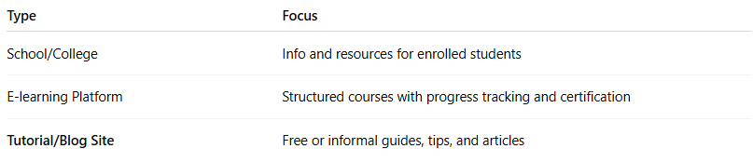
Type | Focus
School/College | Info and resources for enrolled students
E-learning Platform | Structured courses with progress tracking and certification
Tutorial/Blog Site | Free or informal guides, tips, and articles

If you want, I can now create a complete, easy-to-read table of all the website types we’ve discussed so you can see everything in one place and compare them easily.
Do you want me to do that?

